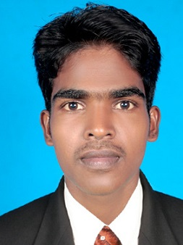**PRAMOTH P**

**Permanent Address:**

4-46, Kollanchi,EttenKattu Vilai ,

Mulankuzhi po,

Kanayakumari-629162,

TamilNadu, India.

**Email:** pramothp1991@gmail.com **Phone:** (+91) 9791639151

**Self Introduction:**

Since graduation in 2013 and completion of one year GAT (Gradute Apprentice Trainee), I have been preparing for SSC Exams like SSC CGL, SSC CHSL, SSC MTS & SSC JE, With this appearances, I’m acquainted with SSC exam patterns and their levels. Also focusing on TNPSC related exams. Still I’m focused on cracking the exam. I can utilize my skills and knowledge efficiently for Organization growth and enhance myself further.

**Educational Qualification:**

|  |  |  |  |  |
| --- | --- | --- | --- | --- |
| **Course** | **Institution** | **Board/**  **UNIVERSITY** | **Percentage of Marks/CGPA obtained** | **Year of passing** |
| **B.E** | Udaya School of Enginering.  Nagercoil , kanayakumari. | Anna University | **8.59** | 2013 |
| **XII** | Vidhya Jyothi Matric Hr.  Secondary school, Nagercoil. | State Board | **80.00** | 2009 |
| **X** | Vidhya Jyothi Matric Hr.  Secondary school, Nagercoil. | State Board | **70.00** | 2007 |

**EXAM EXPERIENCE**:

1. SSC CGL- 2016
2. SSC CHSL -2016
3. SSC CHSL – 2017
4. SSC MTS – 2016
5. SSC JE – 2016
6. RRB exams-2018

Cleared in ssc mts tier 1**

Cleared in rrb alp tier 1**

|  |  |  |  |
| --- | --- | --- | --- |
| **Exam** | **Year** | **Score** | **Cut-off** |
| SSC mts tier 1 | 2016 | 114/150 | 122/150 |
| SSC chsl tier 1 | 2016 | 90/200 | 120/200 |
| SSC JE tier 1 | 2016 | 95/200 | 139/200 |
| SSC chsl tier 1 | 2017 | 102/200 | 139.5/200 |
| RRB group - D | 2018 | Result pending |  |
| RRB ALP | 2018 | Result pending |  |

**UPSC :**

Undergone UPSC 2017-2018 Batch coaching in TEMPZ ACADEMY,

Anna Nagar west , Chennai.

**AWARDS :**

* Toppest percentage during the year 2010-2011
* Got anna university rank of 36th.

**SOFTWARE SKILLS:**

Photoshop  
MS Office (word, excel, power point)

**Declaration:**

I do hereby declare that the particulars of information and facts stated here in above are true, correct and complete to the best of my knowledge and belief.