CURRICULUM VITAE 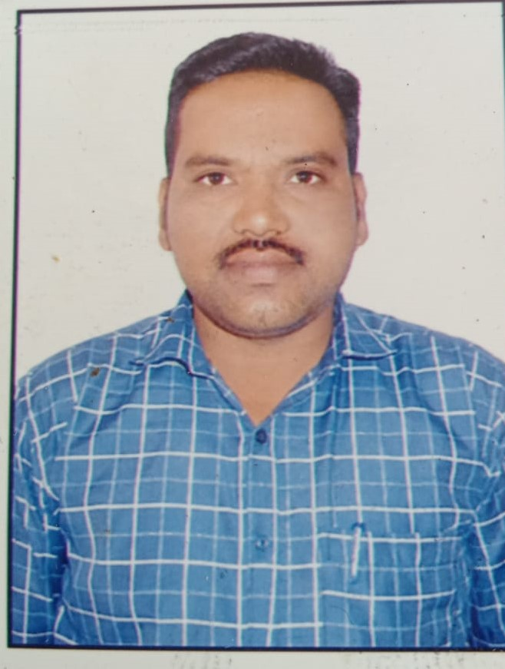
Name : -Jadhao Amol Sitaram
Add :- At/po: Vizora Tal:Barshritakali
District : - Akola
State :- Maharashtra.
Contact No 8806350193/9923951100
Email: amoljadhao97@gmail.com

Objective:-

“Seeking a challenging position, that provides an opportunity to utilize my skills for multiphase professional management development.”

Education Qualification:-
Degree | Institute/ University | Year of Passing | Class Obtained
B.A | Sitabai Art Collagege Akola | April-2009 | B A 1st year
H.S.C. | Pune Board | June 2008 | Second
S.S.C. | Pune Board | 04/20/06 | Second

Computer proficiency:-

- MS- CIT
- Typewriting Speed 30 WPM in English
- Internet activities –surfing and E-mail

Work Experience : -

- Four years experience in Spandana Shorty Financial Ltd. As a Branch Manager
Job Profile : - Group Formation for Loan Disbursements, Give Training to the Group in the Meeting, Document Verification , Loan Disbursement and going to the Centre Meeting for Weekly recovery, Solve the any Centre Meeting Problems, Cashier role, Doing Weekly reports and Monthly reports.
2) Royal Packaging Akola -Corrugated Box Manufacture Industries in Manager Post Sep- 2015 To 30.03.2019
3) Y.N Ware housing Com Akola_ Parle Depot ( As SAP Operator)1 April-2019 To As On Date

Self Assessment:-

- Co-operating Skills.
- Flexible and Hard Work.
- Ability to work under responsibility.

personal Details:-

Father’s Name Jadhao Amol Sitaram
Date of Birth : 01/01/1991

Marital Status : Marrid
Gender : Male
Nationality : Indian
Languages Known : English, Hindi, Marathi.
Languages Speak : Hindi, Marathi , English.
Hobbies : Listening all type songs, Playing and Watching Cricket.
I hereby declare that the above-mentioned information is correct to best of my knowledge.

Date- 22/04/2023
Place- Vizora (Jadhao Amol Sitaram)

