Unable to upload video in admin. NOT DONE

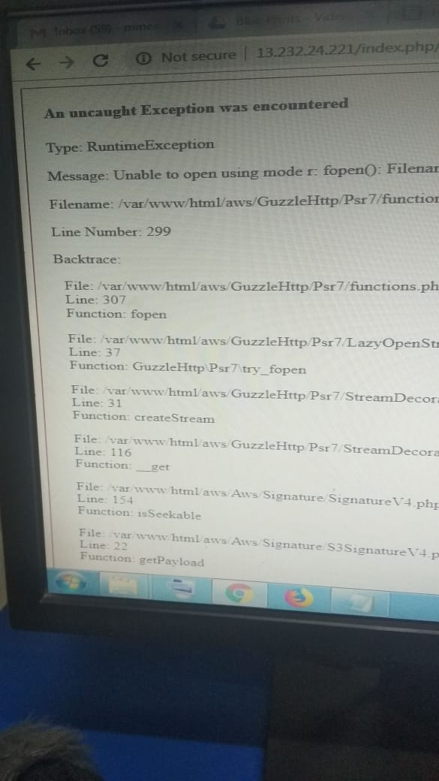

**Suggested Post is Missing**

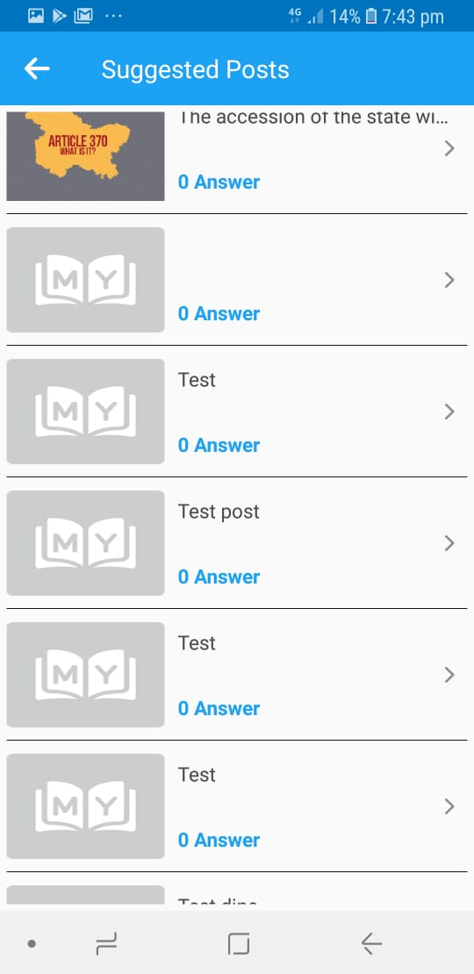

**NOT DONE**

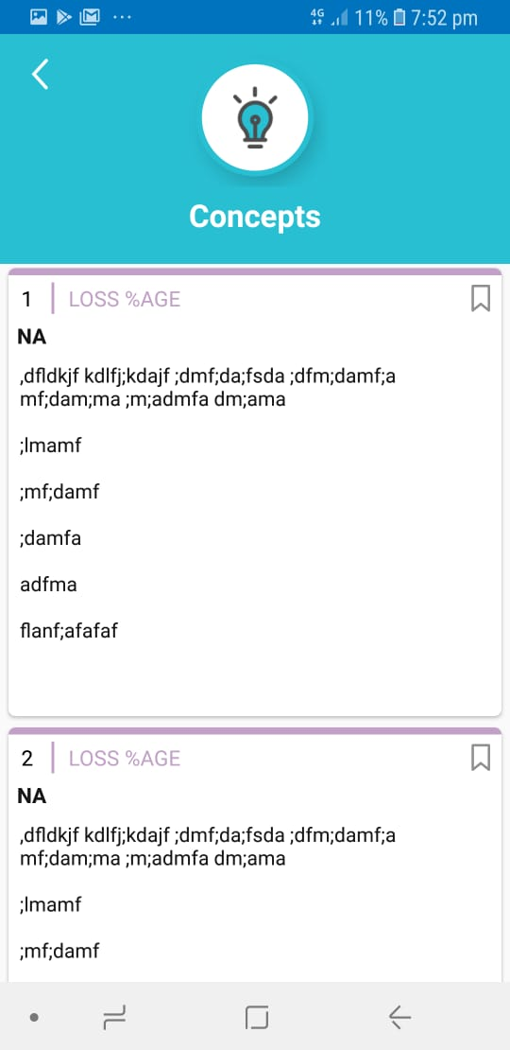

Bookmark Tapping not workkngproperly - **DONE**

App crashed while tapping dowload pdf**DONE**

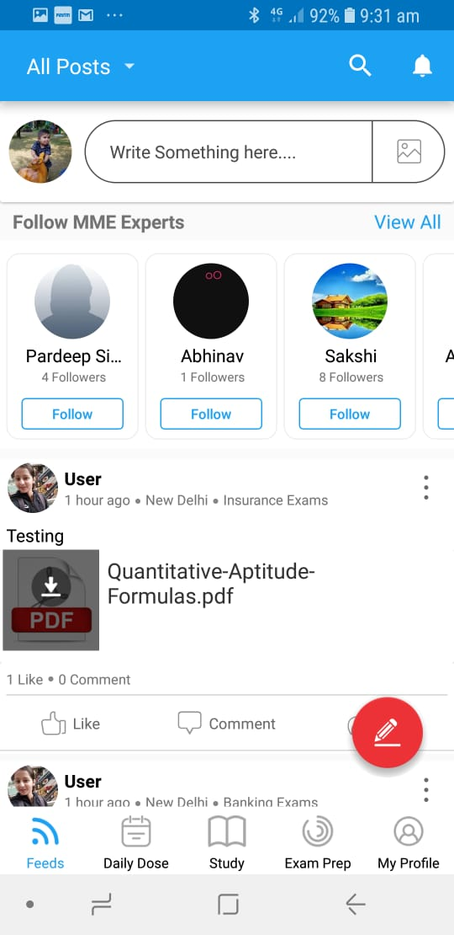

**remove top bar- NOT DONE**

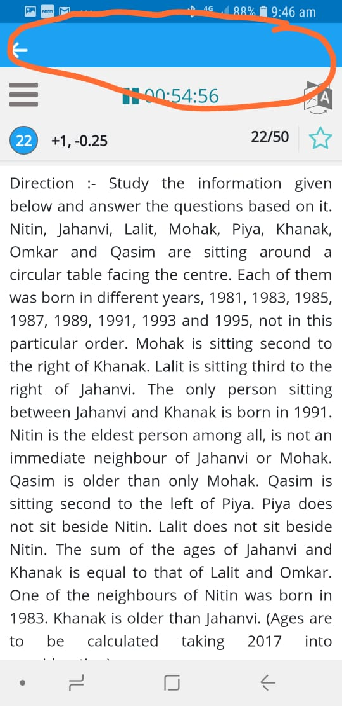

progress bar is not workingWORKINGON IT

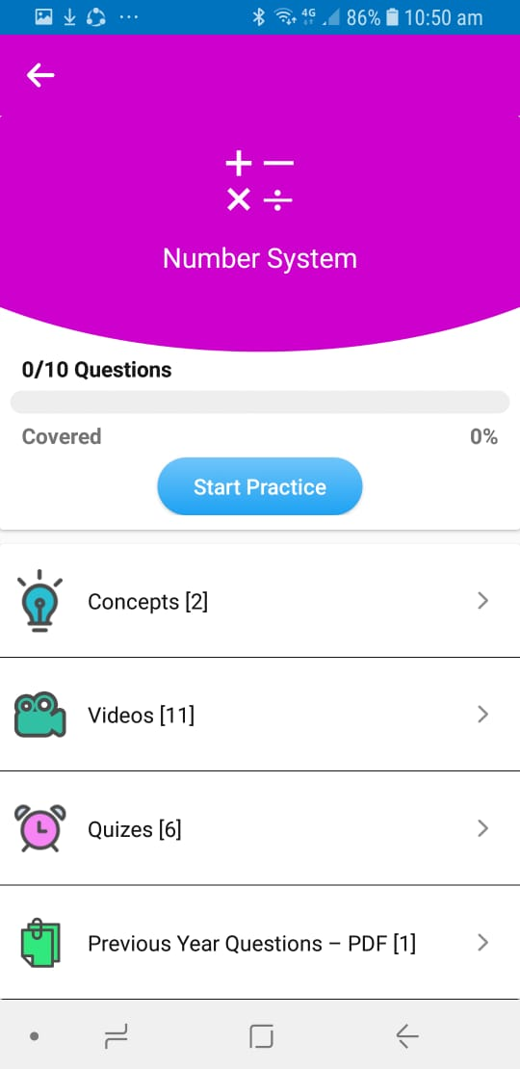

again asking for permission**NOT DONE(WE WILL DO IT ON LATER PART)**

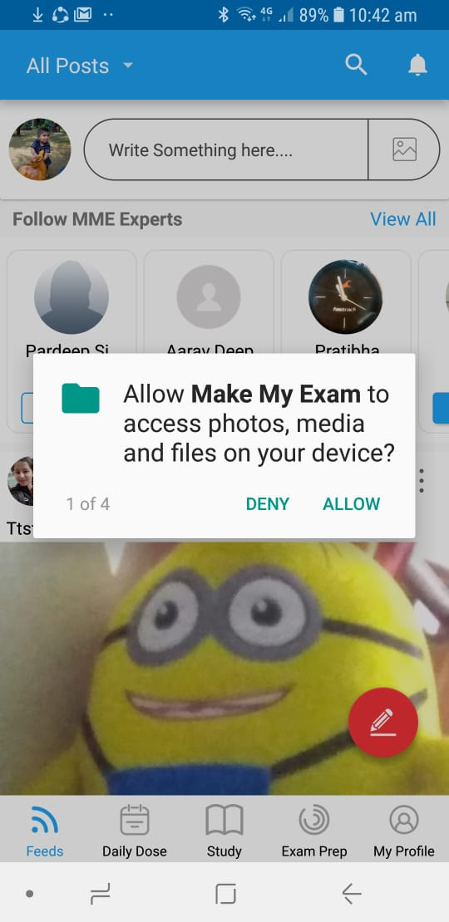

Save notes sometimes working.... and even hard to press... might some tapping issue - **NOT DONE**

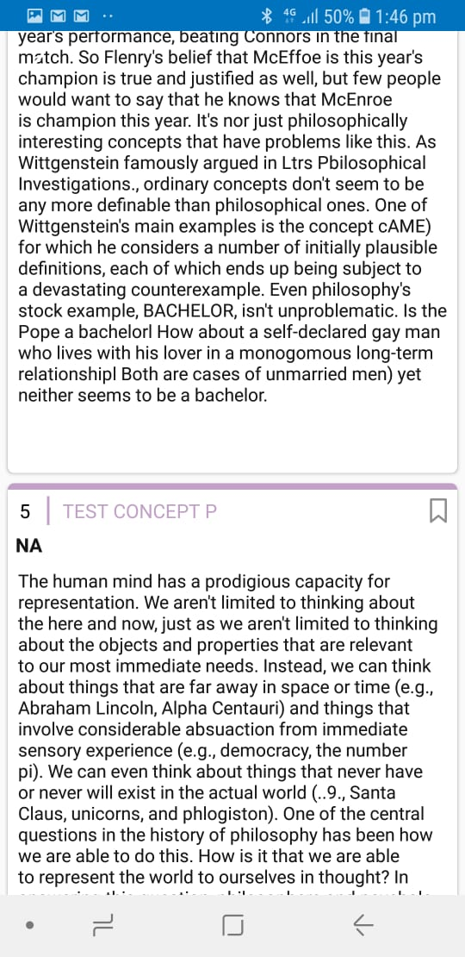

Also keep drop down on the right side**NOT DONE**

Files does not delete in real time . User need to reload the page and do show give message.

“Post is successfully deleted from your Notes”

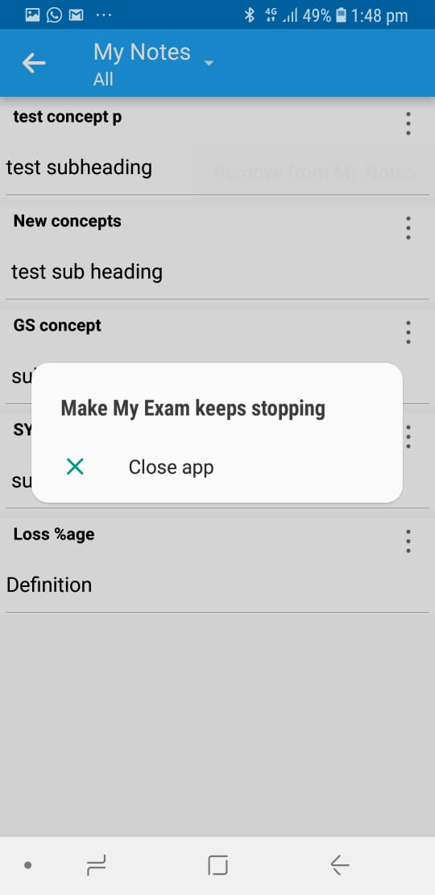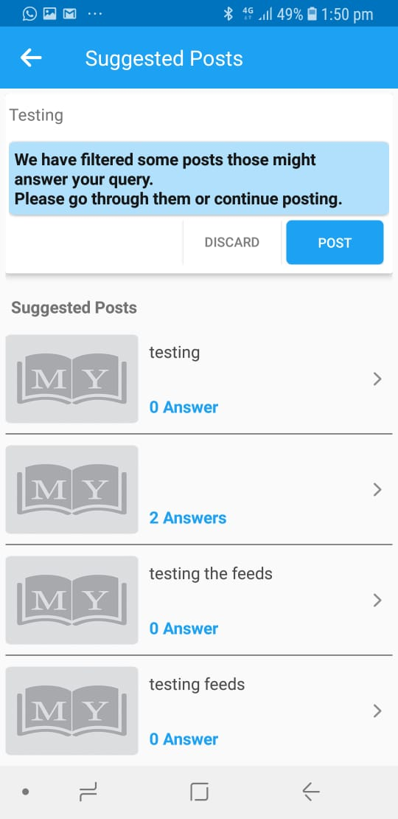

Image missing in suggested posts...... even my logo is stretched horizontally **NOT DONE**

**Suggested Post is Missing**

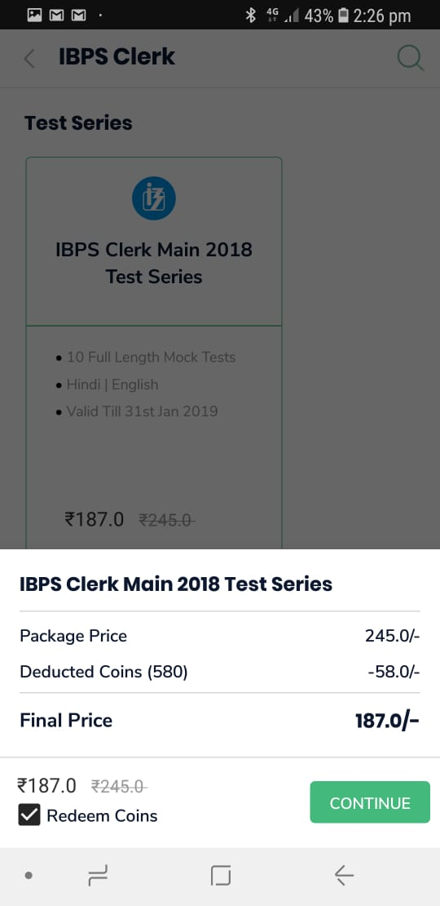

Do give an option to redeem coins while purchasing and redyce the same value from Payment – Not Done

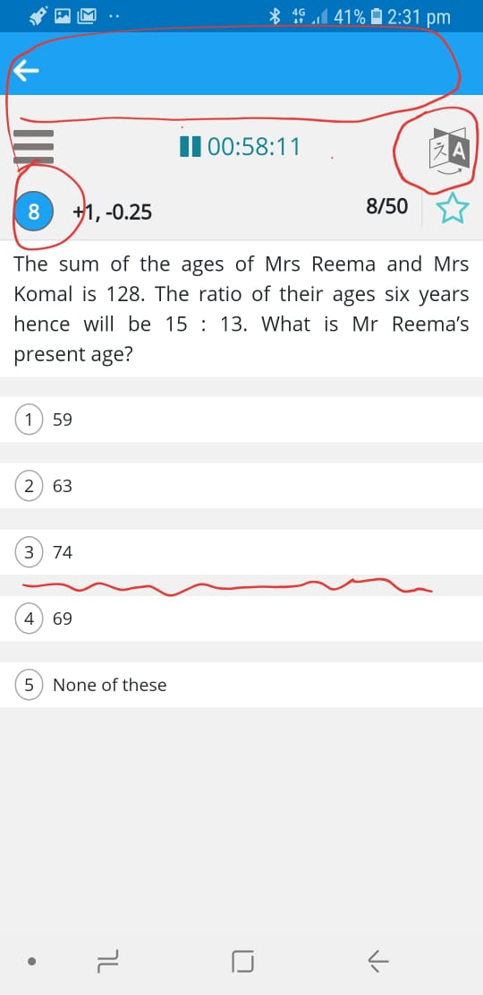

1. Remove blue header – **Not Done**

3. Change language icon **DONE –Showing Blur now**

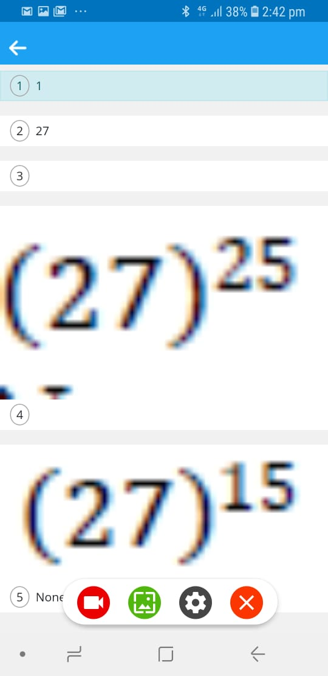 look at the image**NOT DONE**

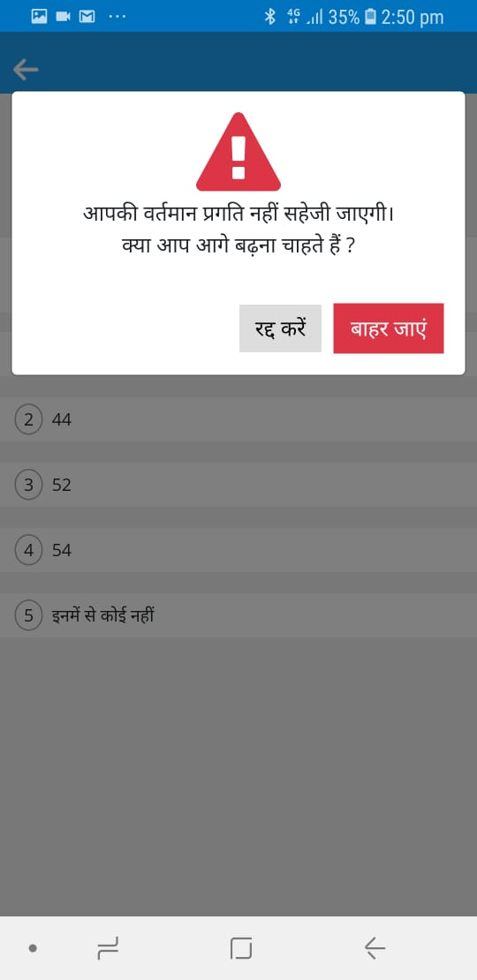

Changing question language also changes app language... see here NOT DONE

Remove downloading video... just stream in app…. NOT DONE

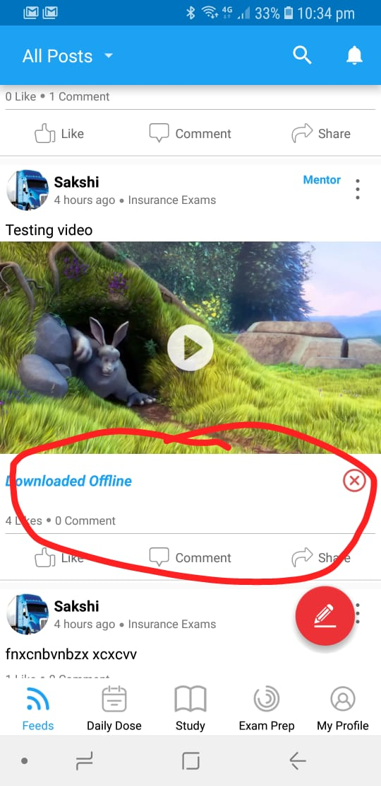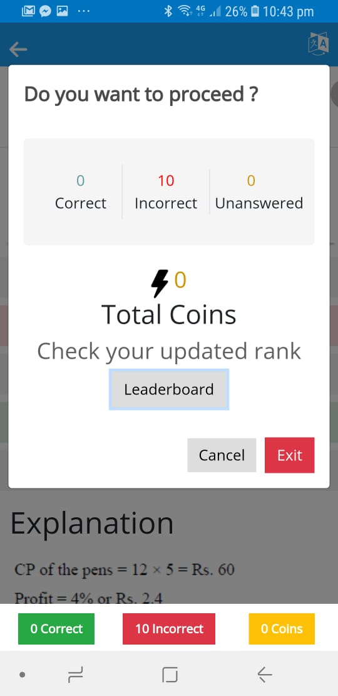

Leaderboard not working in practice - NOT WORKING

While tapping in language on quiz ... screen moves to the left – Not Done

Scrolling upward n downword not working properly

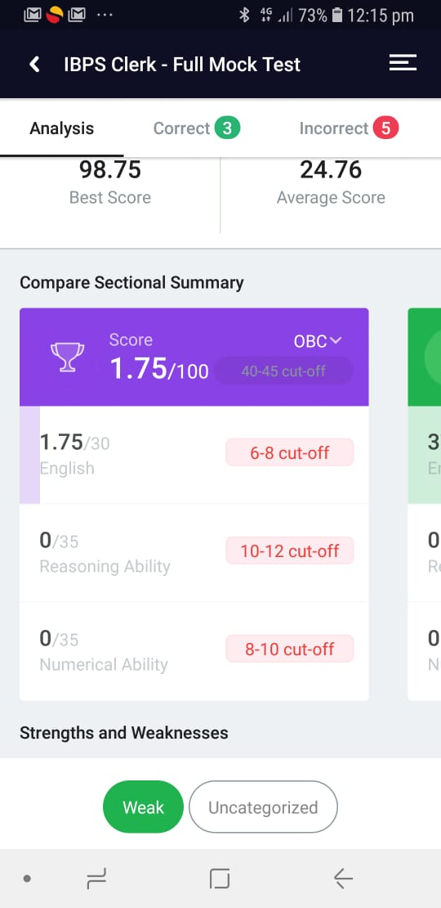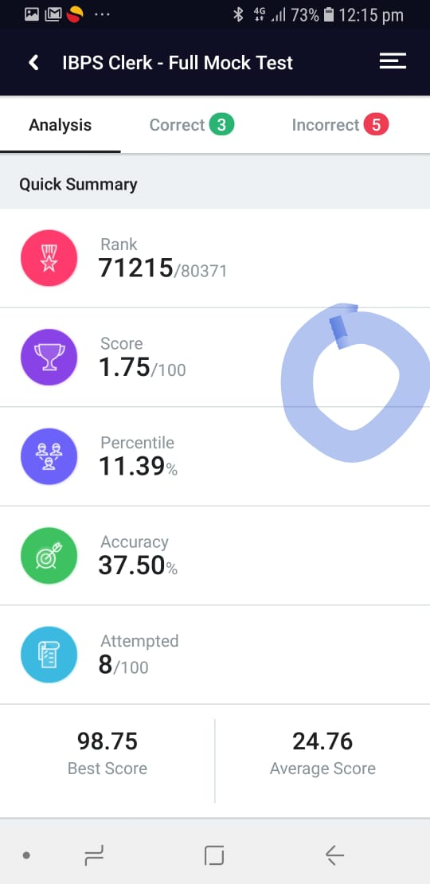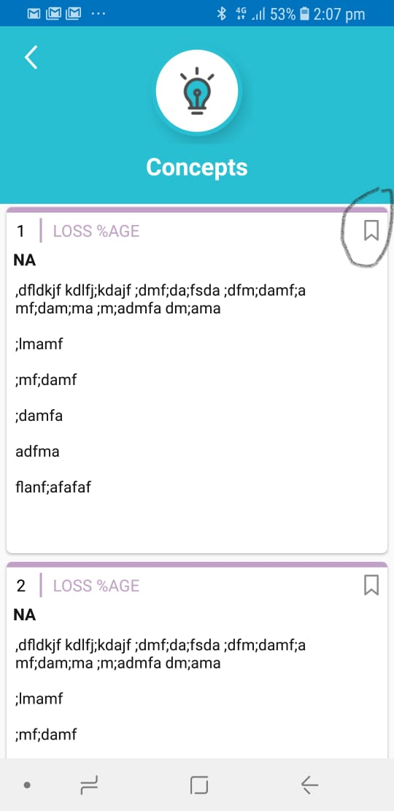

Book mark not working properly in android….. WORKING FINE – NOT WORKING PROPERLY

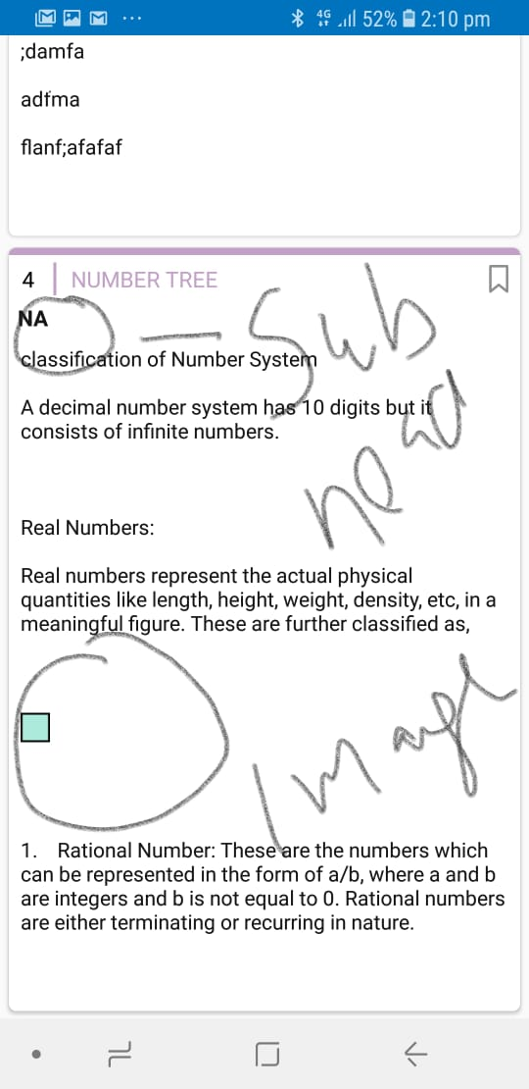

Image not showing in concepts **NOT DONE**

**NEW ISSUES**

**Scrolling Not working Properly –**

**Change loading icon to MY LOGO**

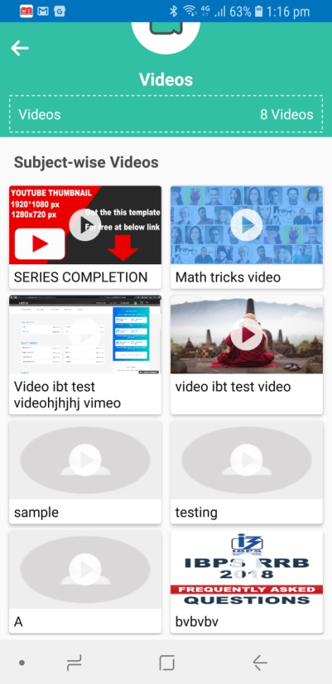

MCQ Created by the user is automatically offering earned coins to the creater.

Note : User can not answer his own mcq , Show given message when he tries to attempt his own MCQ

“ Sorry ! You can not attempt your self created MCQ.”

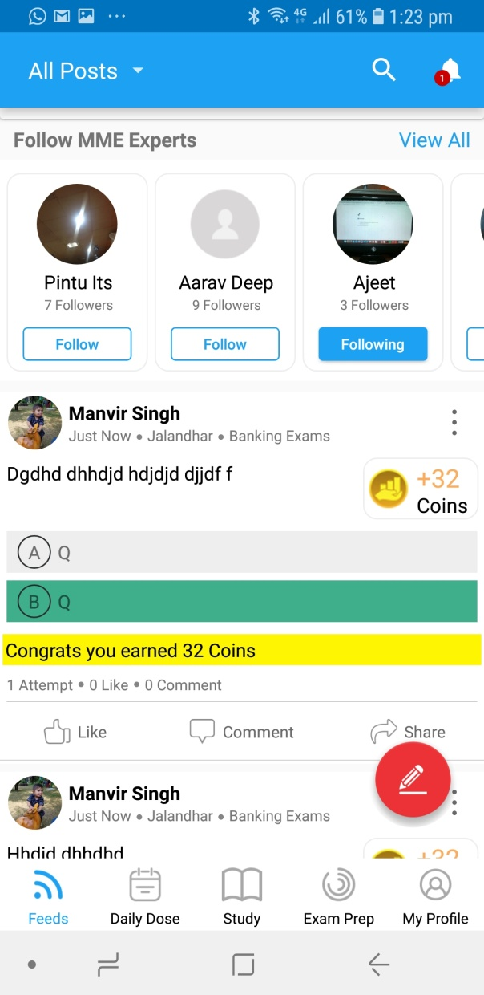

**PRACTICE**

1. **Reduce Upper S.No. Circle Size and make it same as of question no. Circle size**

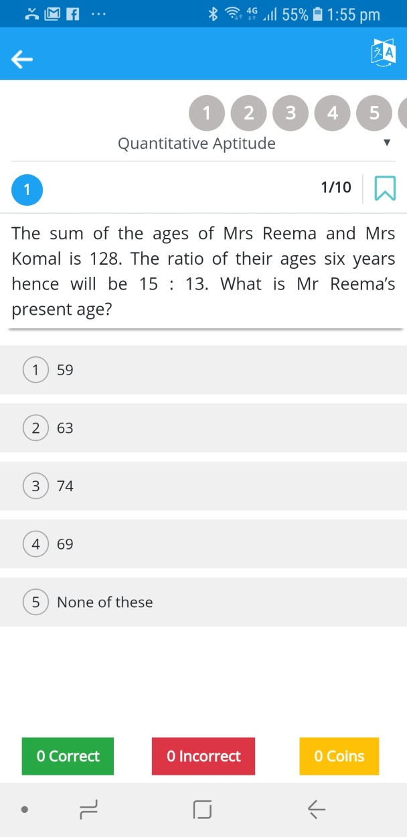

**Start S. NO STREAK FROM THE BEGINNING.**

1. Remove Section drop down as practice is having 1 section only (Quantitative Aptitude)
2. Bottom Back Button is not working , By clicking on bottom button it has to open result.
3. Show Topic name here in the blue bar (Header)
4. Change language icon
5. Explanation is not showing if language changed to hindi and then question is attempted.
6. Direction language like , Correct, Incorrect also changing to hindi once changing question language. It should only be changed once user change app language.
7. On tapping app show yellow color instead of green for correct answer, just for a glance.
8. Saving a single question shows blue color on all questions.
9. Only Show outer circle when user has not reached at the question and once user visited the question then keep the whole part dark see reference below

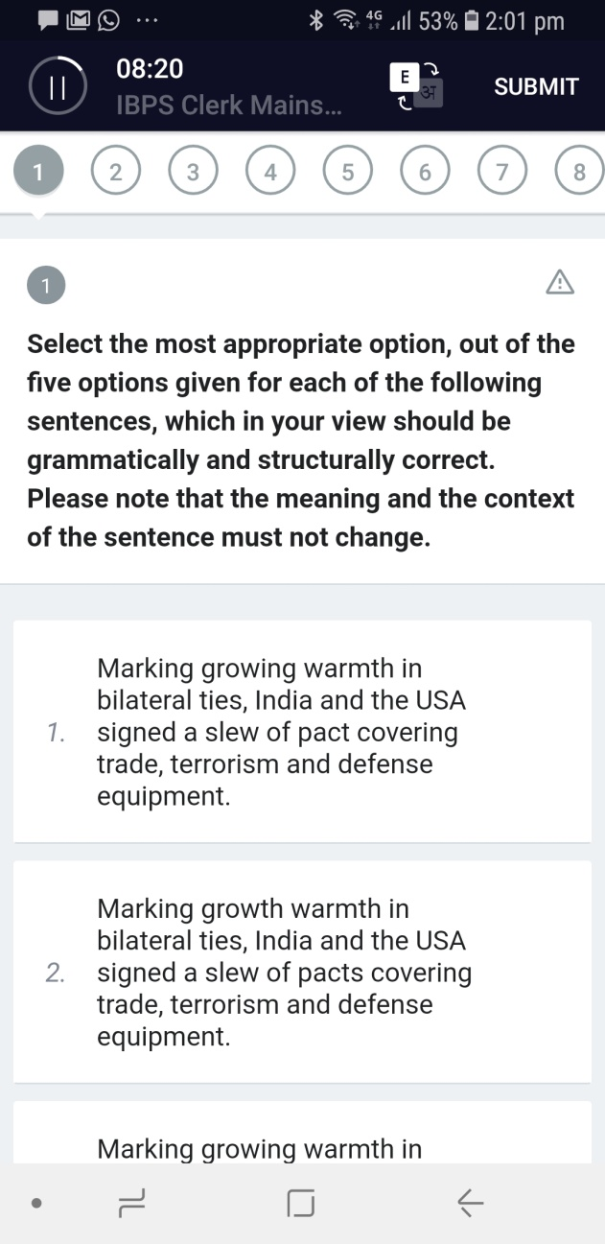

Practice Leader board is not working.

Change Coin logo- Use same logo as of Feed

Reduce Font size

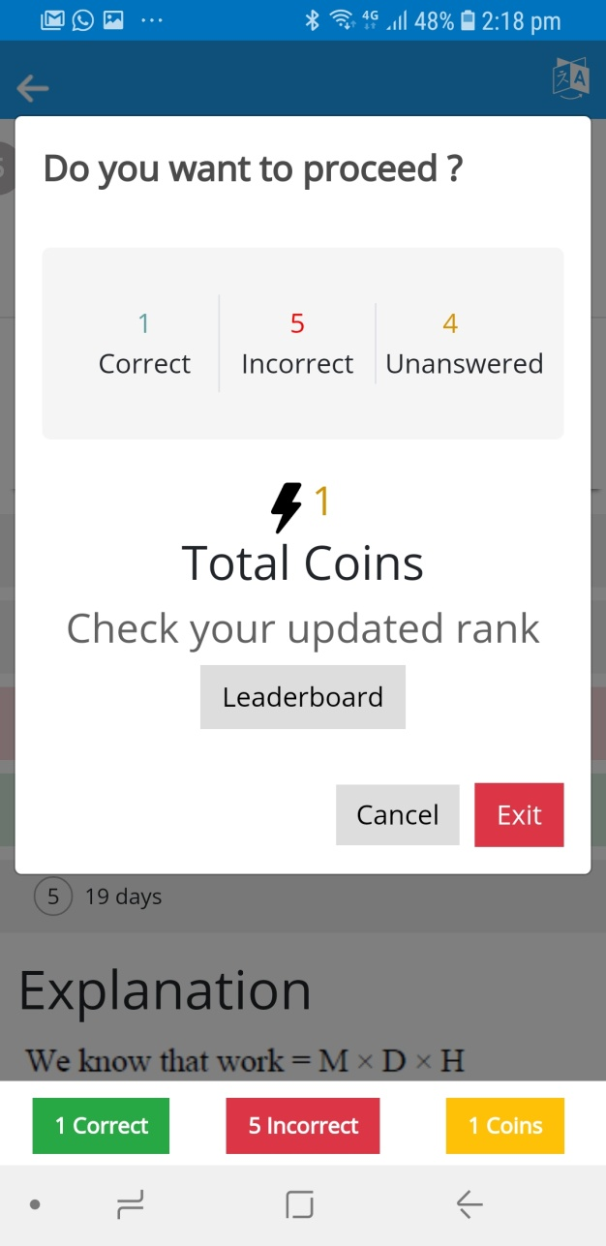

1. Show same Performance screen as of Test Series

Consider give aspects.

RANK

ACCURACY

ATTEMPTED

Leader Board

Practice shows Explanation of all the question once clicked one the option of single question, Even if the question is not attempted.

See question No, 2 – Question Not attempted

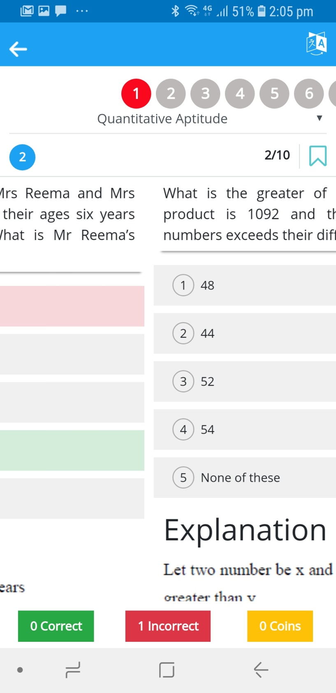

**QUIZ-**

1. Remove Section drop down as practice is having 1 section only (Quantitative Aptitude)
2. Show Quiz name here in the blue bar (Header)
3. Change language icon
4. Only Show outer circle when user has not reached at the question and once user visited the question then keep the whole part dark see reference below
5. Saving a single question shows blue color on all questions.
6. Submit button is missing in the quiz.