**CURRICULUM-VITAE**

#### PRASHANT KUMAR SHARMA

#### Email :- [pkkvmzn@rediffmail.com](mailto:pkkvmzn@rediffmail.com), pkkvmzn@gmail.com

#### *PH*:- +919871629289, 7351378245

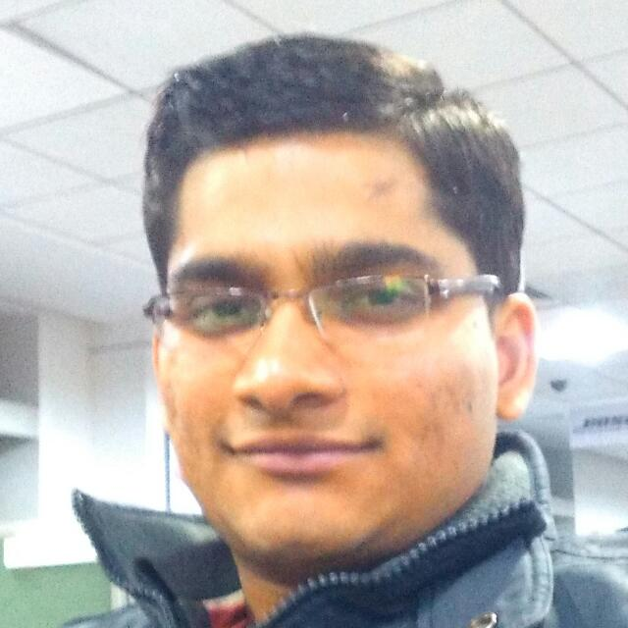

**OBJECTIVE**

Seeking a suitable responsible position in an organization that can provide me an opportunity to prove myself and polish my skills through challenging tasks.

**ACADEMIC RECORD**

|  |  |  |  |  |
| --- | --- | --- | --- | --- |
| **Course** | **year** | **Institution** | **Board / University** | **% Obtained** |
| B.Tech( E.&I.) | 2011-2015 | College Of Engineering Roorkee | UTU | 75.74* |
| Class XII | 2011 | Kendriya Vidyalaya, Muzaffarnagar | CBSE | 66.8 |
| Class X | 2009 | Kendriya Vidyalaya, Muzaffarnagar | CBSE | 85 |

**E.I. - Electronics and Instrumentation * - Honors**

**ACADEMIC PROJECT**

The objective of this project was to design a simple and easy method to operate speed control unit for a D.C. motor. For speed controlling MY Team used PWM technique and for providing stability we designed PID controller in a software called **LABVIEW.** Interfacing to the driver circuit and feedback was provided with the help of NATIONALINSTRUMENT DATA AQUISITION DEVICEcalledas **myDAQ.**

**INDUSTRIAL EXPERIANCE**

I have done Industrial training from **SIGNAL AND TELECOM DEPARTMENT** of **DELHI METRO RAIL COPORATION (DMRC)**. The

training includes Telecommunication, Automatic fare collector and Information Technology used in DMRC. I studied all the

three with both practical and theoretical insight of the equipment used and usage.

**WORK EXPERIENCE**

.

* Currently Teaching Maths,English,Reasoning to Banking SSC and Railway students on freelancer basis.
* Worked as a **Senior Analyst** (Senior software engineer) at **Capgemini Technology Services India Limited** from march’17-nov’17.
* Worked as a **System Engineer** at **Capgemini Technology Services India Limited** from jan’16-feb‘17.
* Worked with **Concentrix (IBM) daksh** in its internal **IT TEAM** for **APPLE** (IOS devices) as an associate from jun’15-jan’16.

.

**ACADEMIC ACHIEVEMENTS**

* Secured **3rd** POSITIONin my batch of **Engineering.**
* Presented paper on '**AUTOMATION OF CELL TOWER GENERATOR USING PLC–SCADA** in **NATIONAL CONFERENCE OF EMERGING TRENDS IN ENGINEERING SCIENCE AND** TECHNOLOGY.
* Secured **2nd position in** BHARTIYA SANSKRITI GHYAN PARIKSHA **-** 2006 in S.D. public school.

**SKILLS**

* **IT Skills –**SCCM basics, windows troubleshooting.
* **Technical Softwares**: Express PCB, Mat-lab (basic), Labview (basic).
* **Operating Systems:** Windows,Macintosh, Android, Ubuntu 14.04lts.
* **Other Softwares:** MicrosoftOutlook,Microsoft office, Active Directory (A.D.).

**CULTURAL AC****HIEVEMENTS**

* Volunteer of the **INTERNATIONAL NGO' THE KARUNA CLUB '**registered at Chennai.
* Volunteer of the NATIONWIDE **CANCER CONTROL PROGRAMME** IN 2009.
* Organised a CULTURAL FEST 'THE NON-VIOLENCE DAY' ON Gandhi Jayanti in College.

**HOBBIES**

**HOBBIES**

* Reading the poems.
* Playing badminton.

**STRENGTH**

* Optimist.
* Self-Motivated.

**PERSONAL DETAILS**

Father’s name : Mr. Fazal Ilahi Ansari

Date Of Birth : 10th Nov’1992

Gender : Male

Nationality : Indian

**Languages known : English, Hindi, Arabic, Urdu**

Father’s name : Mr. ANIL KUMAR SHARMA

Mother's name : Mrs. SAROJ DEVI

Date of Birth : 30/06/1994

Gender : Male

Nationality : Indian

Languages known : Hindi, English

**DECLARATION**

Father’s name : Mr. Fazal Ilahi Ansari

Date Of Birth : 10th Nov’1992

Gender : Male

Nationality : Indian

**Languages known : English, Hindi, Arabic, Urdu**

I hereby declare that information furnished by me is correct and I bear the responsibility for the correctness of above mentioned particulars.

**Prashant Kumar Sharma SIGN:**