1. **GENERAL**

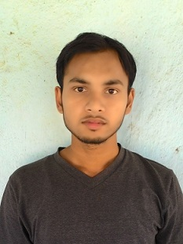

Affix

Photograph

* 1. **Name**:  **PRINCE KUMAR_________________________________________**

##### **Date of Birth**: 1 0 0 2 1 9 9 4 DD/MM/YYYY

##### **Father’s/Mother’s Name:** TARKESWAR PRASAD

##### **Heigh**t: 163 cms **Weight**: 55 kg

**Power of Glasses L ___0___ R ___0____**

##### **Address for Correspondence:** 10/1, BARABAGAN LANE , POST ALAMBAZAR, KOLKATA-700035

##### **E-Mail Id**: [psonukumar95@gmail.com](mailto:psonukumar95@gmail.com) **Cell No:** 7278329080

**Work Experience**

1. **2.5 years of experience as an RF engineer in Reliance Jio Infocomm Limited.**

**2. EDUCATIONAL QUALIFICATIONS**

**2.1** **Secondary & Higher Secondary**

|  |  |  |  |  |  |
| --- | --- | --- | --- | --- | --- |
| **Examination** | Board / Institution | **Year of Passing** | **Marks** | | |
| **Obtained** | **Out of (Total)** | **%** |
| 10th Std | CBSE | **2009** | **416** | **500** | **83.2** |
| 12th Std | CBSE | **2011** | **435** | **500** | **87** |
| B.TECH | NIT DURGAPUR | **2016** | **8.01** | **10** | **75.01** |

**3. SCHOLASTIC ACHIEVEMENTS**

**A) got participation certificate in under 16 and under 19 in cricket at cluster level**

**B) conference out from ssb 2011**

**C) Qualified NTSE.**

**4. ACADEMIC PROJECTS**

**A)Had done project on swarm robotics from IIT MANDI.**

**6. SKILLS AND CAPABILITIES**

**A) Capable of making people understand very easily**

**B) hardworking, can perform under pressure, can learn new things quickly**

**7. POSITIONS OF RESPONSIBILITY**

**A) was school team captain in under 16 cricket tournament.**

**8. EXTRA CURRICULARS**

**A) listening music**

**B)playing cricket**

I hereby declare that the information given above is true and correct.

**DATE: 01-02-2019 SIGNATURE:** 